Inter faith prayer and meditation Earth Vigil
Wednesdays 11am to 3pm outside Parliament

Dear Sisters and Brothers who live in London,

You are invited to come and pray, and hold in intention that MPs hearts and minds are opened to the reality of the climate and ecological crisis and the need to act now. You are welcome to bring your own placards and symbols.

The Earth Vigil is an initiative of the faith communities of Extinction Rebellion. It began with a 24-hour vigil for the 40 days and nights of Lent 2020 – which started in person and continued online due to the pandemic. The most recent vigil was on the streets of Glasgow during the COP 26.

The Wednesday Vigil was begun last year and has just restarted and will take place while Parliament is sitting

4 Religious have regularly taken parts in these vigils: Sr Christiane and Sr Regula (Sisters of St Andrew), Sr Zoe Leadbetter (Carmelite Sister) and Sr Kate Midgley (Columban Sister)

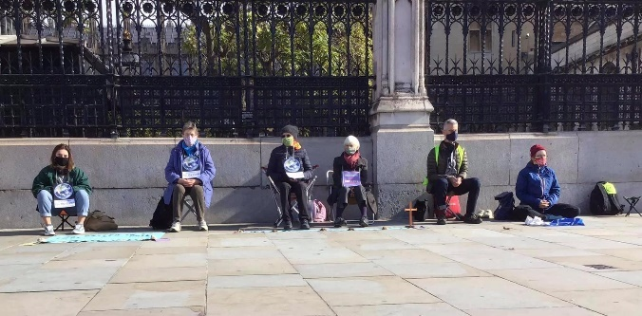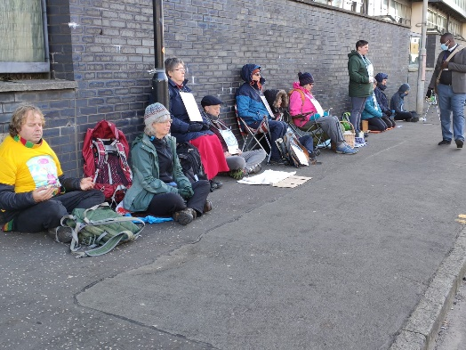

If you would like to come along – for 5 minutes or 50 minutes or whatever, just bring something to sit on and plenty of warm clothes! It is advisable to contact one of us beforehand as, depending on numbers, we might not be there the whole time. Our phone numbers are:
Kate | 07767 216473
Zoe | 07397 917902

“…for we know that things can change” (Laudato Si #13)

Christiane, Regula, Zoe and Kate

